Safety framework architecture

Date: 26-11-2025
Version: 0.2
Status: Review
Author: D. Gijsbers

Version Control
Version | Date | Description of changes
0.1 | 31-10-2025 | Justification classes
0.2 | 26-11-2025 | Introduction, sequence diagrams
0.3 | 01-12-2025 | High-level overview, Traceability

Table of Contents
Safety framework architecture 1
Version Control 2
Introduction 4
Justification classes 5
High-level overview 5
Simfeeder 7
IMediator / Mediator 7
SafetyConfig 8
ISafetyKernel / SafetyKernel 8
ISafetyHandler and Concrete Handlers 9
IRobotPort / Robot 9
Traceability to HARA and safety goals 10
Sequence diagrams 12
Nominal control tick (no hazards) 12
STOP path (human intrusion triggers SSM) 13
Communication loss (fail-safe) 15
System init & Shutdown 16

Introduction
The safety framework architecture in this document explains how the safety-related software of Robot One is built, how its parts work together, and how it makes safety decisions. Robot One is an autonomous farm robot that works in changing environments where people, animals, obstacles, and uneven terrain are always present. In such conditions, safety cannot rely on a single feature like an emergency stop or a geofence. It requires a complete system that constantly checks for risks and ensures safe behaviour.
This architecture is based on earlier work: the project plan, the literature study on safety in autonomous robotics and standards, and the Hazard Analysis and Risk Assessment (HARA) done for Robot One. The HARA identifies key hazards such as collisions, leaving the working area, tool misuse, and communication loss. These hazards are turned into safety goals and requirements, which are then linked to software tasks, limits, and fail-safe rules inside the safety framework. This creates a clear connection between each hazard and how it is handled in the software.
The goal of the architecture is to create a modular, testable, and standards-aligned safety core that can run both in simulation and on the real robot. To do this, the design uses well-known patterns such as the Mediator and the Chain of Responsibility. The main components are: a simulation/feed adapter (SimFeeder), a Mediator that manages the flow from sensor data to robot commands, a SafetyKernel that checks hazards using a chain of safety handlers, a SafetyConfig that stores safety limits from the HARA, and a RobotPort that sends safe commands to the robot. Together, these components make sure that every movement or action goes through one clear, auditable safety decision process.
Finally, this document describes the tasks and fail-safe rules of each class and includes sequence diagrams that show how the system behaves in different situations: normal operation, human intrusion, communication loss, and system start-up and shutdown. This gives Pixelfarming Robotics engineers a clear guide for implementation, testing, and future improvements of the safety framework, while keeping it aligned with the identified hazards and safety standards.

Justification classes
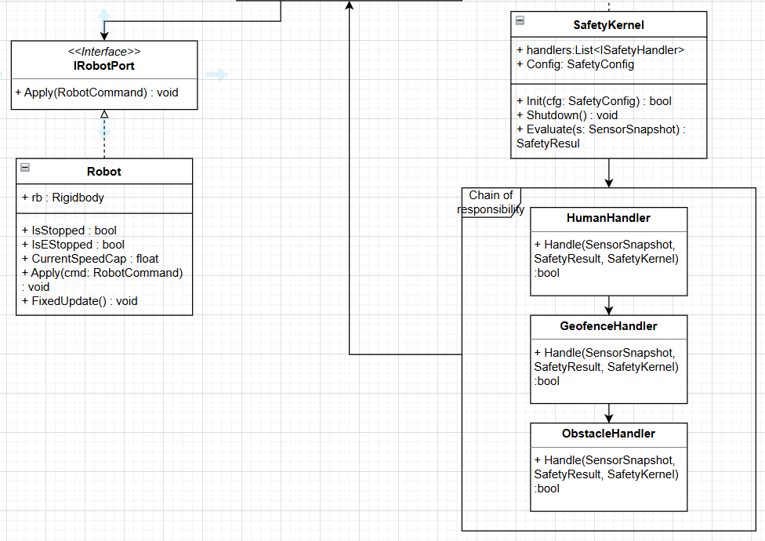
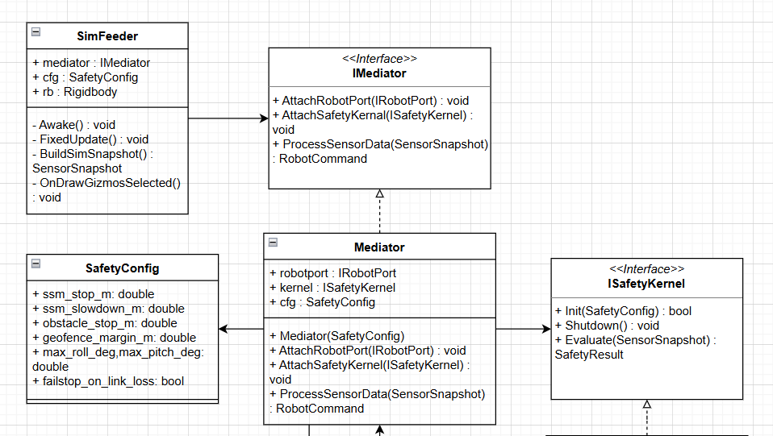

High-level overview
The safety framework is designed as a modular layer that sits between the robot’s environment (Sensors, simulation) and the robot’s actuators(drive, tools). Its main responsibility is to ensure that all motion and actuation commands are evaluated and gated by safety logic before they reach the platform. The architecture is intentionally decoupled from specific hardware so that the same safety logic can run both in the Unity simulation and later on the real Robot One.
At high level, the framework consists of the following main components:
- SimFeeder: provides the safety framework with a unified view of the robot and its environment. In the simulation this includes robot pose, velocity, geofence status, object detection and other relevant signals. These raw inputs are aggregated into a SensorSnapshot that represents the current situation.
- Mediator: Orchestrates the control cycle. It receives the latest SensorSnapshot from the feeder passes it to SafetyKernel, receives a SafetyResult back and combines this with the nominal control command to produce the final RobotCommand for the platform.
- SafetyKernel: The core decision-making component. It implements a Chain of Responsibility of individual SafetyHandlers. Each handler inspects the SensorSnapshot, may update the current safety state and can escalate the response form OK to SLOW, STOP or ESTOP according to configured rules.
- SafetyConfig: The central configuration and policy store. It contains thresholds, timeouts, distance margins and state transition rules derived from the HARA and safety requirements. The SafetyKernel and its handlers use this configuration to ensure that safety behaviour remains consistent, traceable and easy to adjust without changing the code.
- RobotPort: The abstraction layer towards the robot platform. It receives the final RobotCommand from the Mediator and applies it to the actual actuators (or simulated actuators). This ensures that all motion passes through a single auditable interface that enforces the SafetyKernel’s decisions.
During each control tick, the data and control flow is as follows:
- The SimFeeder collects the lastest sensor and state information and constructs a SensorSnapshot.
- The Mediator passes this snapshot to the SafetyKernel.
- The SafetyKernel processes the snapshot via its chain of SafetyHandlers, using SafetyConfig to decide if the situation is safe, requires speed reduction, a controlled stop or an emergency stop. The result is returned as a SafetyResult.
- The Mediator combines the SafetyResult with nominal command from the robot’;s main controller and generates a final, safety-approved RobotCommand.
- The RobotPort executed this command on the platform, ensuring that unsafe commands are blocked or overridden by the safety decisions.
Because the feeder and port are abstracted behind interfaces, the same SafetyKernel and configuration can be reused in different execution environments. In the current stage, the implementation is focused on Unity-based simulation for development, testing and validation. Later, alternative implementations of the feeder and port can be provided to connect the same safety core to the real Robot One hardware, while preserving the architecture and behaviour described in this document.

Simfeeder
Role: Unity-facing input adapter that builds a SensorSnapshot each physics tick and forwards it to the mediator.
Why: Separates simulation/hardware timing from safety logic, enables identical safety core in sim and on real hardware.
Key responsibilities:
- Collect physic data from the simulator or hardware abstraction.
- Construct SensorSnapshot (pose, speed, detections, link status, slopes, etc.).
- Forward the snapshot to Mediator.ProcessSensorData().
Fail-safe policy: If a snapshot cannot be built, publish a degraded snapshot or signal ‘no data’ so the mediator/kernel defaults to Stop.
Verification: PlayMode/integration tests ensure repeatable snapshots, correct rates/units and graceful behaviour on missing data.

IMediator / Mediator
Role: Orchestrator that isolates modules and converts SensorSnapshot tot SafetyResult to RobotCommand.
Why: Mediator pattern prevents tight coupling and enforces a single safety gateway before actuation. It also simplifies substitution and testing.
Key responsibilities:
- Attach IRobotPort and ISafetyKernal, holds SafetyConfig.
- Call kernal.Evaluate(snapshot) to obtain a SafetyResult.
- Map SafetyResult to a RobotCommand(OK,SLOW,STOP,E-STOP).
- Apply the command through IRobotPort.Apply().
- Log decisions for auditability.
Fail-safe policy: On kernel error/timeout or invalid snapshot it emit a conservative command (Stop/E-Stop).
Verification: Integration tests with synthetic snapshots assert correct command mapping and fail-safe dominance.

SafetyConfig
Role: Central set of thresholds and policies derived from the HARA assessment.
Why: Makes safety policy explicit, version able and traceable tot hazards/requirements.
Key responsibilities:
- Expose parameters such as ssm_stop_m, ssm_slowdown_m, obstacle_stop_m, geofence_margin_m, max_roll_deg, max_pitch_deg, failsafe_on_link_loss.
- Provide read-only (or controlled) access to avoid runtime drift.
- Version and document parameter provenance.
Fail-safe policy: Configuration values are validated at init. Out-of-range values cause safe initialization failure (system remains in safe state).
Verification: Boundary and equivalence tests verify parameter ranges and mapping back to HARA requirements.

ISafetyKernel / SafetyKernel
Role: Safety decision engine that runs a Chain of Responsibility (CoR) of hazard handlers and returns a SafetyResult.
Why: CoR provides open/closed extensibility and deterministic, auditable decisions from a single point.
Key responsibilities:
- Maintain ordered handles: Human -> Geofence - > Obstacle -> …
- Evaluate snapshot and aggregate the most restrictive outcome (E-Stop > STOP > SLOW > OK).
- Expose rationale (which handler/threshold triggered).
- Initialize and shut down safely, manage handler lifecycle.
Fail-safe policy: Any handler/kernel fault or ambiguity yields a conservative SafetyResult ( Stop or E-Stop).
Verification: Kernel tests with handler stubs verify ordering, escalation rules and fault containment.

ISafetyHandler and Concrete Handlers
Role: Pluggable hazard checks that can tighten the safety state.
Why: Each Hazard class maps to its own, testable unit aligned with HARA categories.
Key responsibilities:
- HumanHandler: Speed & Separation Monitoring (SSM) -> SLOW/STOP when thresholds are breached.
- GeofenceHandler: Enforces workspace boundaries/margins -> STOP outside.
- ObstacleHandler: Distance/path prediction vs obstacles -> SLOW/STOP.
- Extend with rollover, Link-Loss, Tool-Inhibit, etc.
Fail-safe policy: Handlers return early on decisive outcomes. Errors propagate as conservative decisions.
Verification: Unit tests for every handler with edge cases, noisy inputs and parameter sweeps.

IRobotPort / Robot
Role: Actuation boundary that applies RobotCommand to the platform/simulator.
Why: Decouples decision intent from hardware specifics, enables swapping sim/real implementations and test doubles.
Key responsibilities:
- Apply speed caps, controlled stops, E-stop and tool inhibits.
- Expose diagnostic state (IsStopped, IsEStopped, CurrentSpeedCap).
- Ensure safety-state dominance over non-safety requests.
Fail-safe policy: Once STOP/E-STOP is active, only the safety path can clear it. Loss of comms leads to a safe state per config.
Verification: PlayMode tests assert braking/hold behaviour, state dominance and correct interaction with physics/drivers.

Traceability to HARA and safety goals
The design of the safety framework is directly based on the Hazard Analysis and Risk Assessment (HARA) for Robot One. In the HARA, possible hazards in the farm environment — such as collisions with humans or animals, leaving the field boundary, or losing communication — are identified and analysed by looking at how often they can happen (exposure), how serious the outcome would be (severity), and how easily they can be controlled (controllability). These hazards are then turned into safety goals and functional safety requirements. The architecture makes sure that each safety goal has a clear place in the software, so the robot’s behaviour can always be traced back to the original risk analysis.
For each main hazard category in the HARA, a matching safety goal is defined and linked to one or more parts of the safety framework: a specific SafetyHandler in the SafetyKernel, settings in SafetyConfig, and, when needed, behaviour in the RobotPort. For example, the hazard of colliding with a human leads to the safety goal that the robot must slow down or stop when a person enters its protective zone. This is handled by the human-detection and speed-and-separation (SSM) handlers in the SafetyKernel, which use configurable distance limits and reaction times from SafetyConfig to decide whether the situation is safe (OK), requires slowdown (SLOW), a stop (STOP), or an emergency stop (ESTOP).
Hazards related to leaving the defined work area are linked to safety goals for geofencing. The HARA specifies that the robot must not cross certain boundaries and must only operate inside safe zones. In the architecture, this is handled by the geofence handlers in the SafetyKernel. They check the robot’s position against the geofence areas and margins defined in SafetyConfig. If the robot gets too close to or crosses a boundary, the handler changes the safety state and triggers a slowdown or stop command through the RobotPort.
Hazards involving obstacles, terrain, or stability — such as collisions with static objects or operating on steep or uneven ground — are managed by the obstacle and slope handlers. These use sensor data like distance maps, object detections, and pitch/roll angles from the SensorSnapshot, and compare them with limits set in SafetyConfig (for example, maximum slope or minimum safe distance). When a threshold from the HARA is exceeded, the handler updates the safety state so that the robot either adjusts its command or stops completely.
System-level hazards, such as communication loss or sensor failure, are handled by communication and diagnostic handlers, as well as by the default behaviour of the SafetyKernel. The HARA defines that if control or sensor data are missing or unreliable, the robot must switch to a safe state. This is implemented through timeouts, heartbeat monitoring, and plausibility checks defined in SafetyConfig. If one of these fails, the SafetyKernel sets the system to a safe mode (STOP or ESTOP), and the RobotPort sends a matching safe command to the platform.
By organizing the safety framework around these handlers and a central SafetyConfig, every safety decision can be traced step by step — from hazard → safety goal → safety requirement → software element. This clear traceability supports safety documentation, makes reviews and audits easier, and allows safe updates when the HARA, safety goals, or operating conditions of Robot One change in the future.

Sequence diagrams

Nominal control tick (no hazards)
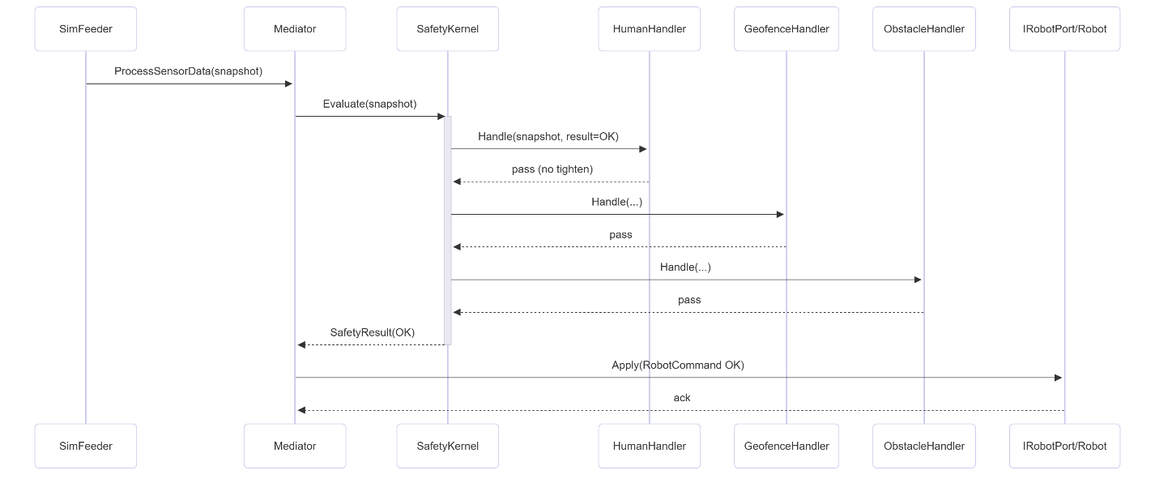
In the nominal scenario, the robot operates within its allowed area, at an acceptable speed and with no detected hazards. The sequence diagram for this case visualises one control tick of the safety framework:
- The SimFeeder collects the latest simulation or sensor data (robot pose, velocity, geofence status, object detections, communication status, etc.).
- SimFeeder aggregates this raw data into a SensorSnapshot, representing the current situation at time t.
- The Mediator requests the latest SensorSnapshot from SimFeeder at the start of the control tick.
- The Mediator passes the SensorSnapshot to the SafetyKernel and asks for a safety evaluation.
- The SafetyKernel iterates over the configured SafetyHandlers (e.g. human/SSM, geofence, obstacle, slope, communication).
  - Each handler inspects the SensorSnapshot and consults SafetyConfig for its thresholds and rules.
  - Because this is a nominal case, all handlers determine that their conditions are within safe limits and do not escalate the safety level.
- The SafetyKernel combines the results of all handlers into a single SafetyResult. In this scenario, the result is typically OK or a non-restrictive mode (e.g. OK or SLOW with a permissive speed limit).
- The Mediator receives the SafetyResult and combines it with the nominal control command from the robot’s main controller (for example, a desired velocity vector).
- Based on the SafetyResult, the Mediator generates a final RobotCommand that is allowed by the current safety mode (e.g. full speed or limited speed).
- The RobotPort receives the RobotCommand and applies it to the simulated or real actuators (drive, tools).
- Optionally, the Mediator and/or SafetyKernel log the snapshot, result and command for traceability and debugging.
This sequence demonstrates that even in nominal operation, all actuator commands are always passed through the SafetyKernel before reaching the platform.

STOP path (human intrusion triggers SSM)
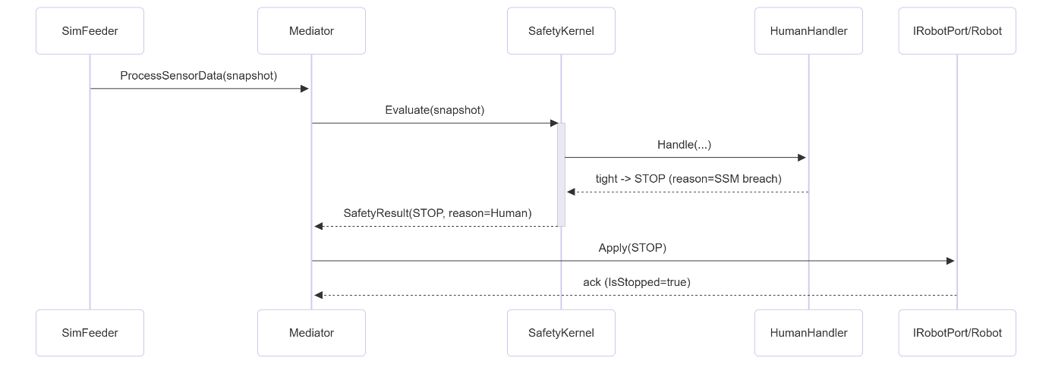
In this scenario, a human enters the protective field around the robot, causing the safety framework to initiate a controlled stop or emergency stop according to the Speed and Separation Monitoring (SSM) rules. The corresponding sequence diagram extends the nominal flow with an escalation path:
- The SimFeeder receives updated environment data in which a human detection (or equivalent representation) is present near the robot.
- SimFeeder constructs a new SensorSnapshot that includes the human’s position, robot speed and any other SSM-relevant signals.
- The Mediator obtains this snapshot and forwards it to the SafetyKernel.
- Within the SafetyKernel, the human/SSM SafetyHandler is invoked as part of the handler chain.
  - The handler reads the human position and robot motion state from the SensorSnapshot.
  - It retrieves SSM parameters from SafetyConfig, such as minimum allowed distance for the current speed, reaction time, and braking capability.
  - The handler calculates the required separation distance and compares it with the actual distance between robot and human.
- If the actual distance is too small, or predicted to become too small within the configured reaction time, the handler escalates the safety level (for example from OK to SLOW, or from SLOW to STOP/ESTOP).
- The SafetyKernel evaluates the outputs of all handlers and produces a SafetyResult that now indicates a STOP or ESTOP state, plus any relevant metadata (e.g. reason: “Human intrusion / SSM violation”).
- The Mediator receives this SafetyResult and overrides or clamps the nominal control command from the main controller.
  - Instead of the requested motion, it generates a RobotCommand that enforces braking to standstill or immediate shutdown, depending on the configured behaviour for STOP vs ESTOP.
- The RobotPort applies the commanded stop to the actuators. In case of ESTOP, this may imply a more abrupt or hardware-level stop.
- The SafetyKernel and/or Mediator can latch the STOP/ESTOP state, so that the robot remains stopped until conditions have been verified as safe again and a reset procedure is performed.
- The event (human detection, escalation decision, final command) is logged to support traceability and later safety analysis.
This sequence shows how a single hazardous detection in the environment is propagated through the safety chain and ultimately results in a safe stop of the robot.

Communication loss (fail-safe)
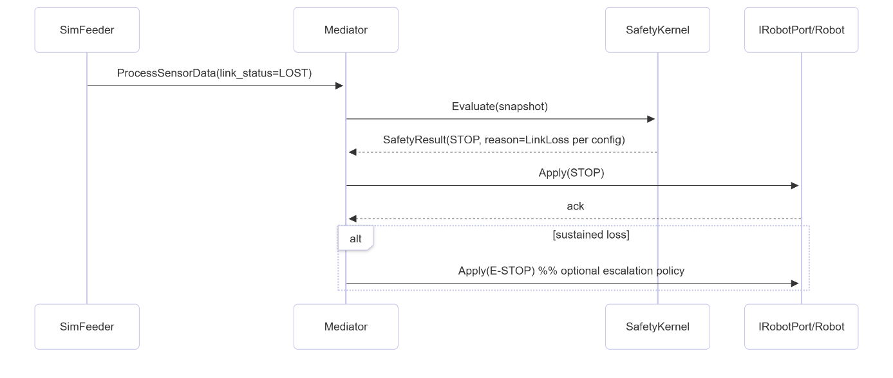
This scenario covers the case where communication with the main controller or an essential sensor is lost. The safety framework must then transition the robot to a fail-safe state. The sequence diagram illustrates this process:
- Under normal operation, the SimFeeder (or a dedicated communication monitor within the safety framework) receives periodic heartbeat messages or status updates from the main controller and critical sensors.
- For each control tick, these heartbeats and timestamps are included in the SensorSnapshot (for example as “last seen” times or communication status flags).
- The Mediator passes the SensorSnapshot to the SafetyKernel as usual.
- In the SafetyKernel, a communication-loss SafetyHandler evaluates the relevant fields in the snapshot:
  - It checks the time since the last valid command or heartbeat.
  - It consults SafetyConfig for maximum allowed communication gaps or timeouts.
- When the elapsed time exceeds the configured timeout, the communication-loss handler flags a fault and escalates the safety level to a predefined fail-safe state (typically STOP or ESTOP).
- The resulting SafetyResult is returned to the Mediator, indicating that normal control must no longer be trusted and that a safe stop is required.
- The Mediator ignores any nominal control commands from the main controller (which may be missing or outdated) and generates a fail-safe RobotCommand that brings the robot to a halt.
- The RobotPort executes this command, stopping motion and possibly disabling further actuation until communication is restored and the system is reset according to the safety procedure.
- The communication-loss event, including timestamps and the chosen response, is logged so that it can be linked back to the HARA and safety requirements.
Through this sequence, the architecture guarantees that loss of communication does not result in uncontrolled or undefined behaviour, but always leads to a controlled safe state.

System init & Shutdown
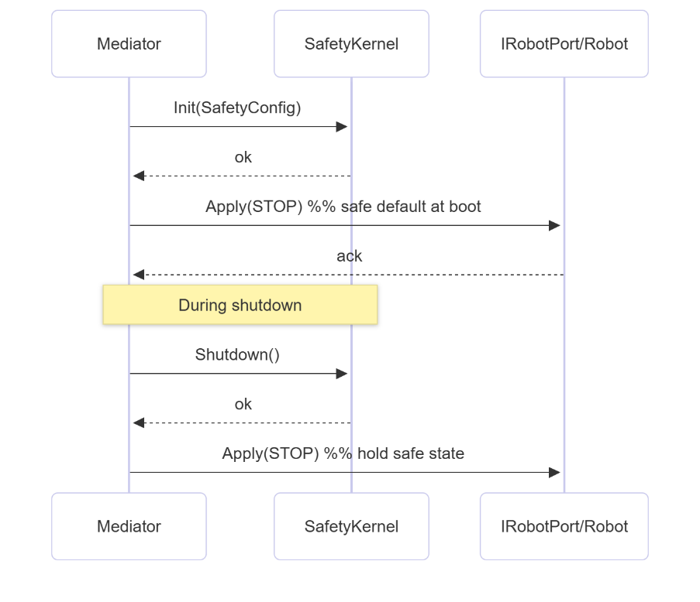
The final scenario describes how the safety framework behaves during system start-up and shutdown. The sequence diagram shows the main phases.
System initialisation
- The SimFeeder, Mediator, SafetyKernel, SafetyConfig and RobotPort are constructed and initialised in a defined order.
  - SafetyConfig is loaded first so that all subsequent components have access to the required parameters.
  - The SafetyKernel registers its SafetyHandlers, each of which reads its configuration from SafetyConfig.
- The Mediator sets the initial safety state to a conservative mode (for example INIT or STOP) so that the robot does not move until all checks have passed.
- The SimFeeder performs any necessary start-up routines (e.g. connecting to the simulation, validating that required data streams are available).
- The Mediator performs an initial health check by requesting a SensorSnapshot and passing it through the SafetyKernel.
  - If critical data is missing or handlers detect invalid conditions, the system remains in a safe non-operational state.
- Once all required conditions are met (valid config, data streams, communication, no active hazards), the SafetyKernel transitions the internal safety state to a READY mode. The Mediator can then allow motion commands to be processed, while still respecting all safety rules.
System shutdown
- When a shutdown is requested (either by the main controller, operator input, or as part of a test), the Mediator initiates a controlled stop:
  - It sets a target safety state (e.g. STOP) and ensures that the next control ticks generate stop commands, regardless of nominal motion requests.
- The SafetyKernel supports this by treating shutdown as a high-priority condition that prevents re-entry into motion states.
- The RobotPort receives the stop commands and brings the robot to standstill. Only once the platform confirms that motion has stopped, higher-level components proceed with final shutdown steps.
- After the robot is safely stationary, the Mediator and RobotPort can close connections, release resources and mark the safety framework as inactive.
- The final state and any relevant diagnostics are logged, so that the complete life cycle (from init to shutdown) is traceable.
These init and shutdown sequences ensure that the robot never starts moving before the safety framework is fully initialised and that it always returns to a safe state before the system is powered down or reset.

